Brine to Wine Race Information
Course Map with approximate km markings
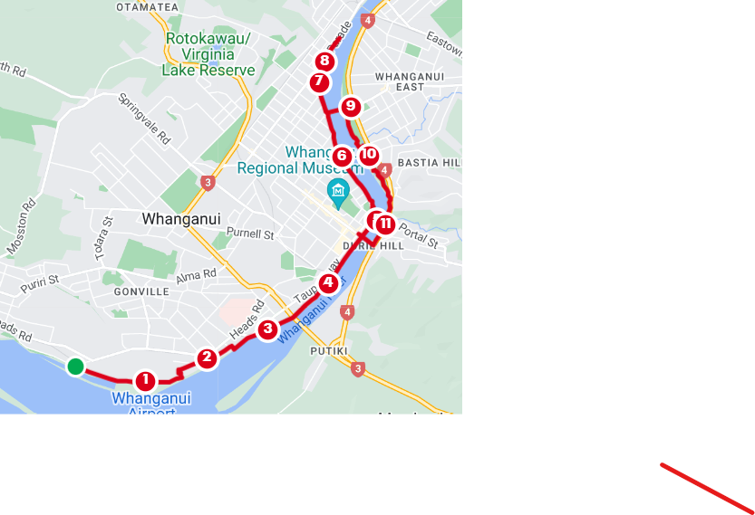
Change over points:
Start = Sailing Wanganui clubrooms
3km = Riverbank walkway opposite Mason Terrace
6km = Somme Parade opposite Riverside Motel
9km = Whanganui East side of Dublin St Bridge
12km = Silver Ball Sculpture, Moutoa Quay

Safety Information:
- All roads are open and all competitors compete at their own risk
- Use a footpath/shared pathway wherever they are available but be aware that the footpaths/shared pathways are open to other users (please be considerate)
- Headphones/music devices are not recommended
- Surfaces are uneven in places
- Be extra vigilant when turning off Dublin St Bridge and going underneath the Dublin St Bridge. There is no shared pathway in this area. Move onto the shared pathway as soon as it is available. There are 2 places where you will then need to cross the road in Kowhai Park. Give way to traffic. To access the stop bank after Kowhai Park, stay within the cones beside the park road
- Take care when turning on and off the bridges as these turns are tight
- Competitors under 11 years of age must be actively supervised by a caregiver aged 16 years or older.
There is a water stop at the 6km mark.
We look forward to seeing you all at Stellar Restaurant and Bar after the event.
Finishers aged 18 years and over will be issued a ticket at the finish line which can be redeemed for a free drink at Stellar from 10:00am. Those aged Under 18 will be given a can of fizzy. Additional drinks are available to purchase at Happy Hour prices. Snacks will be available to purchase at Stellar.
Prizegiving will be at Stellar at approx. 11:00am. A range of spot prizes will be drawn.
Thanks to Stellar Restaurant and Bar for their support of the Brine to Wine. Why not stay on for lunch after prizegiving?

12KM Brine to Wine Individual Entry Form Bib Number:
Name
Age
Gender | MALE FEMALE
Category | RUN WALK
Email Address
Emergency Contact

I declare that:
- I am in an appropriate physical condition to participate in the Event, given the known parameters of the Event (such as the length, time, physical demands and environmental context).
- I have taken medical advice on any pre-existing medical conditions, and confirm that it is medically safe for me to participate in the Event.
- I acknowledge that there are risks involved in the Event. I fully realise the dangers of participating in the Event, and fully assume the risks associated with my participation and my wellbeing and safety during and after the Event. I understand and acknowledge that the Event organisers (including all officials and event volunteers) provide no warranties, regarding my wellbeing and safety.
- I understand and agree that situations may arise during the Event, which may be beyond the immediate control of the Event organisers (including all ofﬁcials and event volunteers).
- I will participate in the Event, in a manner that does not endanger either me or others.
- I agree that to the extent permissible by law, the Event organisers (including all officials and event volunteers), and other parties associated with the Event, have no liability to me whatsoever for any direct or indirect loss, (including, but not limited to injury or death) sustained by me during or in any way related to my participation in the Event.
- I authorise the use of my name, picture and information on this entry form in any broadcast, promotion, advertising, and in any other way, without payment to me or any other form of compensation.
- I agree to comply with the rules, and regulations pertaining to the Event.
- I agree to follow all reasonable safety instructions provided to me by the Event organisers, (including all officials and event volunteers) before, during and after the Event.
- I consent to receiving medical treatment in the event of illness or injuries suffered during or immediately after the Event.

Signed:…………………………………………………………………………………………………………..……
(Signature of caregiver if entrant is aged under 18)

Date:…………………………………………………………………………………………………………………..

Brine to Wine Team Entry Form Bib Number:
Team Name
 | Names | Ages | Genders
1
2
3
4
Category | RUN WALK RUN/WALK
Email Address
Emergency Contact

I declare that:
- I am in an appropriate physical condition to participate in the Event, given the known parameters of the Event (such as the length, time, physical demands and environmental context).
- I have taken medical advice on any pre-existing medical conditions, and confirm that it is medically safe for me to participate in the Event.
- I acknowledge that there are risks involved in the Event. I fully realise the dangers of participating in the Event, and fully assume the risks associated with my participation and my wellbeing and safety during and after the Event. I understand and acknowledge that the Event organisers (including all officials and event volunteers) provide no warranties, regarding my wellbeing and safety.
- I understand and agree that situations may arise during the Event, which may be beyond the immediate control of the Event organisers (including all ofﬁcials and event volunteers).
- I will participate in the Event, in a manner that does not endanger either me or others.
- I agree that to the extent permissible by law, the Event organisers (including all officials and event volunteers), and other parties associated with the Event, have no liability to me whatsoever for any direct or indirect loss, (including, but not limited to injury or death) sustained by me during or in any way related to my participation in the Event.
- I authorise the use of my name, picture and information on this entry form in any broadcast, promotion, advertising, and in any other way, without payment to me or any other form of compensation.
- I agree to comply with the rules, and regulations pertaining to the Event.
- I agree to follow all reasonable safety instructions provided to me by the Event organisers, (including all officials and event volunteers) before, during and after the Event.
- I consent to receiving medical treatment in the event of illness or injuries suffered during or immediately after the Event.

Signature of all team members:……………………………………………………………………………………………………..
(Signature of caregiver if entrant is aged under 18)

…….…………………………………………………………………………………………….…………Date:……………….……

